Catsfield, Crowhurst, Telham, Ashburnham and Penhurst Conservatives

CHAIRMAN’S EVENING QUIZ

The RED LION
HOOE
TN33 9EW
Tuesday
23rd May
7pm

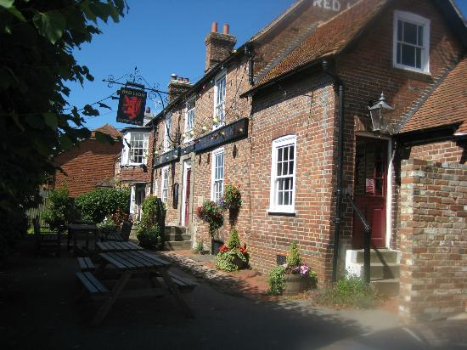
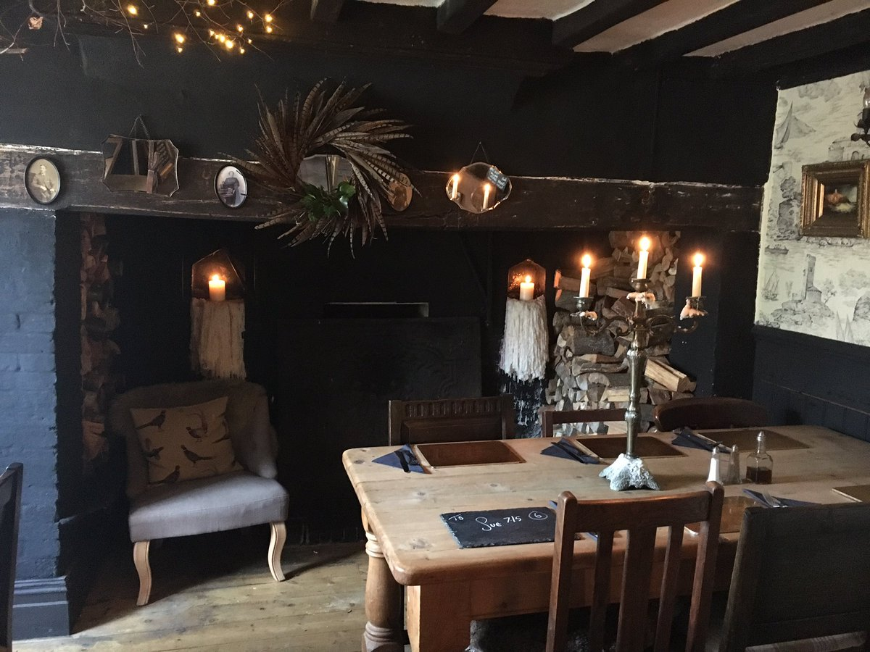
Crowhurst, Catsfield, Telham, Ashburnham and Penhurst Branch
The Red Lion is 500 year old lovely unspoilt traditional pub right in the middle of Hooe village. It has a great reputation for food and was awarded 2nd Best Pub of the Year by the Observer in 2015 and by courtesy of the landlords, Leigh and Natalie Harding a quiz has been arranged.

David would like to invite you to submit a team or teams to join us for a fun evening.

The participation fee of £10 per person includes a hot supper.

All questions will be team based. Teams of 4 would be ideal for the venue,

Could you please kindly let me know if you are planning to submit teams and if so how many people will be attending, or if you would just like to come along support us.

Please pay on the night

Thank you

David Foster
01424 830601
fosterdavid@btinternet.com

