Conservatives

Crowhurst, Catsfield, Telham, Ashburnham and Penhurst Branch

MONDAY PUB
LUNCH
9th APRIL 2018
12 noon for 12.30pm

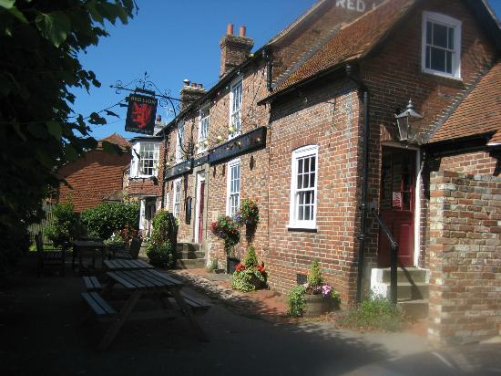
THE RED LION AT HOOE TN33 9EW
(THIS 500 YEAR OLD PUB IS OPENING JUST FOR US)

Please send the completed slip below along with your cheque made payable to CCTAP Conservatives, asap or telephone Kirsty on 01424 892881 or e-mail her on kirstycurtis@gmail.com with your menu choices and pay on the day. Thank you

To Kirsty Curtis, Broomham Barn, Catsfield TN33 9DL

Please reserve………places at £17.50 each for the Pub Lunch on April 9th

Main courses …… by code M……. Deserts ….. by code D…..
Main courses …… by code M……. Deserts ….. by code D…..

Name………………………Address……………………………………………………

Tel………… Email………………………………………

I am unable to attend but would like to make a donation of £………….

Two Course lunch £17.50 per person
Coq au Vin (M1)
Fish Pie (M2)

Apple Crumble (D1)
Bread and Butter Pudding (D2)

RAFFLE.

