Bexhill and Battle
Conservatives

Crowhurst, Catsfield, Telham, Ashburnham and Penhurst Branch
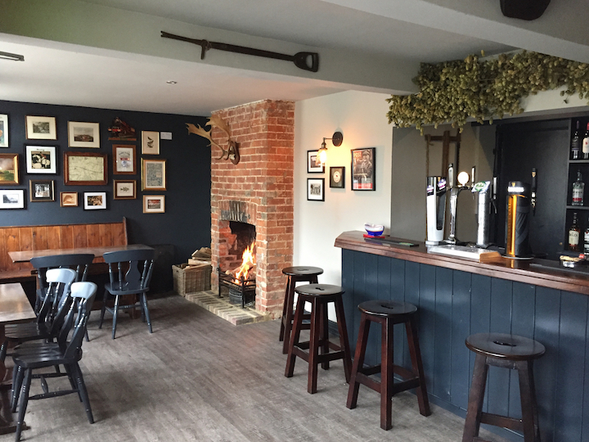
CONSERVATIVE POLICY FORUM MEETING
Friday 20th NOVEMBER
12 noon for 12.30pm
The White Hart
Netherfield
TN33 9QH

Please come along and air your views!!!!

Drinks can be purchased from the bar. A Senior Citizen’s lunch is available with a choice of several dishes. Two courses for £9.95, one course for £7.95, please order at the bar as soon as you arrive ideally at 12 noon. I hear that it is excellent.

It would help to know numbers in advance of the meeting. Please inform the BBCA office at office@bbca.uk.com if you plan to attend.

Please join us !!!

Angharad Davies Vice Chair Political BBCA
aed45@tiscali.co.uk 01580 831969

HOUSING

