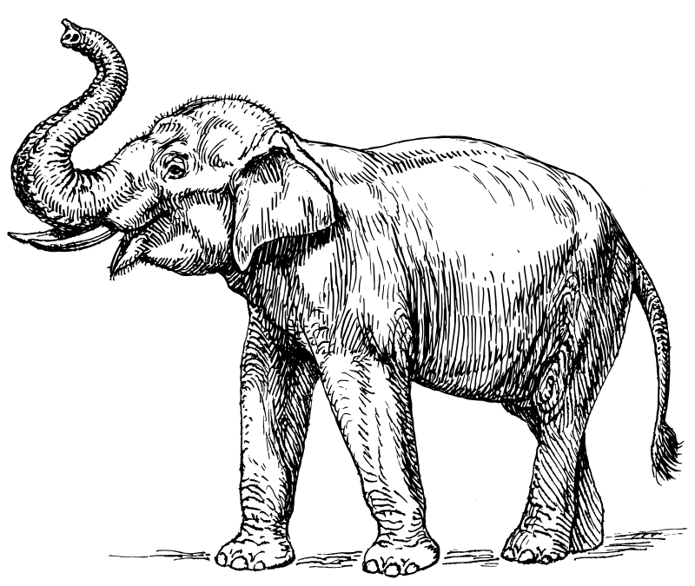

Rother Levels Conservative Association
Trumpeting a new summer event!

Sunday Buffet Lunch
9th June
12.30 for 1 pm

at “Sahebs” Station Road Northiam TN31 6QT . Speaker Baroness Debbie Stedman-Scott of Rolvenden, Deputy Lord Lieutenant of Sussex , Chief Executive of the charity Tomorrow’s People. Admission by pre-paid ticket. Raffle. Please book places for yourself and friends and family as soon as possible using the form at the end of this flyer .

This is a new and exciting event for us this year. Baroness Stedman-Scott is a witty and broad ranging speaker with over 30 years experience in the charitable sector .She is a regular participant in the House of Lords debates from the Conservative benches.

Sahebs have agreed to allow us to hold this lunch as a private function. Sahebs is conveniently situated near the Northiam station of the Kent & East Sussex Railway which will be running steam trains that weekend along the line from Tenterden to Bodiam via Northiam. Almost opposite the restaurant in Station Road is the Mill Toy & Pedal Car Museum, which holds the Guiness Book of Records award for the largest collection of pedal powered model vehicles in the world with over 400 examples.

Why not make a day of it in Northiam?

Buffet Menu :

Lamb Gosht Massala

Vegetable Bhuna

Chicken Makanwalla

Side dishes of Nan, Rice, Plain Popodums, chutney and Raitha

Fruit Salad and Indian Ice Cream

Coffee or Tea

………………………………………………………………………..

To Mrs Zai Koder
The Oast House Hope Farm, Hobbs Lane, Beckley TN31 6TU
Tel : 01797 260677
peterandzai@btinternet.com

Please reserve………. Places at £16 each for the Buffet Lunch at Sahebs Station House Station Road Northiam TN31 6QT

Please make cheques payable to Rother Levels Conservative Association and send to Zai at the above address.

£……………….enclosed Donation £…………………

Name:…………………………………………………………….
Address:………………………………………………………….
……………………………………………………………………
E mail address:…………………………………………………...

I/We wish to have an English style main course instead of Indian food Yes/No

